
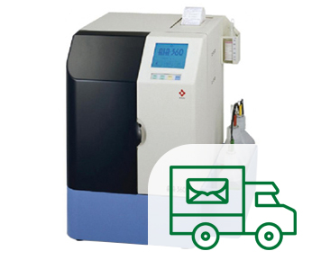
Progesterone (P4) Laboratory Services.
Thank you for your interest regarding the services we offer.
We recommend all samples to be sent by Royal Mail Special Delivery Service or by Courier. Cost per sample £48.00. Results telephoned through the next working day.
Sampling
Ask your vet to collect 1ml of venous blood into the brown top blood tube in the UK is typically known as the serum separating tube (SST) or a gel/serum tube. The tube should be capped immediately and labelled with the owner’s name, animal’s name and date of the sample.
Labelling and Documentation

- Wrap the sample tube(s) in absorbent material (tissue or cotton wool) and place in a biohazard bag. Please do not place adhesive tape around the sample tubes.
- Place the completed request form inside the envelope.
- Place the sample inside "triple packaging" that complies with Packing Instruction P650 for UN 3373 Biological Substance, Category B, which are the standard regulations for diagnostic specimens. The sender is responsible for ensuring compliance.
The packaging must consist of three layers:
- Primary Receptacle: A leak-proof and shatter-proof container (e.g., a screw-cap tube designed for medical use) that holds the sample.
- Secondary Packaging: A durable, leak-proof container or sealed plastic bag that encloses the primary receptacle(s). If multiple primary receptacles are used, they must be individually wrapped or separated to prevent contact and breakage.
- Absorbent Material: Sufficient absorbent material (e.g., cotton wool, paper towels, or an absorbent pad) must be placed between the primary and secondary packaging to absorb the entire contents in case of leakage.
- Outer Packaging: A rigid outer box (cardboard or plastic) that protects the secondary packaging from physical damage during transit. At least one surface of the outer package must have minimum dimensions of 100mm x 100mm.
The outer packaging must be clearly and visibly marked with the following:
- The UN 3373 hazard diamond symbol (at least 50mm x 50mm). see below.
- The text "Biological Substance, Category B" in letters at least 6mm high, placed adjacent to the diamond symbol. See below.
- When the sample has been analysed, we will telephone you with the result.

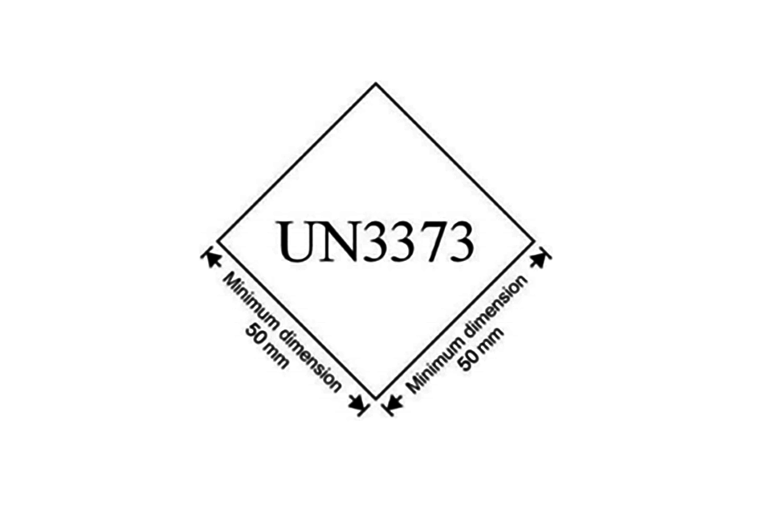
“Biological Substance, Category B"

Fit And Fertile Ltd Laboratory Services
Fit And Fertile Ltd, Fernlands, Burton Road, Tewitfield, Carnforth, LA6 1JH
T: 01524 951441 / 01772 690014 M: 07973 415088 e:fitandfertile@aol.com
www.fitandfertile.com www.breedmydog.net
Please complete the information in BLOCK CAPITALS
NAME OF DOG:
BREED:
SAMPLE DATE:
DAY OF CYCLE:
OWNERS NAME:
ADDRESS:

TELEPHONE NUMBER: Email address:

Veterinary Practice Name, Address & Contact Telephone details: -

Payment Details.
We accept all major credit and debit cards. Cost per test £48.00.
CARD NUMBER:
EXPIRY DATE:
3 DIGIT SECURITY CODE:
NAME ON THE CARD:

